1. SQL server and connecting servers
   1. SSMS(SQL server management studio is the client to connect the SQL server)
   2. Database services, analysis services, Reporting services and Integration services
   3. 127.0.0.1 or .refer to the local machine.
   4. SQL server authentication and windows authentication
   5. Object explorer and query window
2. Altering and drop a database
   1. A database can be created using Graphical SSMS or a query
   2. Every database contains MDF and LDF file
      1. MDF – master data file contains the actual data
      2. LDF – log(Transaction) data file used to recover in case of any DB crash
   3. Drop or delete a database
      1. Right click and delete
      2. Using query
      3. We can delete a database, only when the database has no connection established.
      4. Cannot drop a system database.
3. Creating and working with tables
   1. Create a table person and gender with a foreign key constraint(both query and SSMS)
4. Adding default constraint
   1. Adding a default value to a column.
   2. 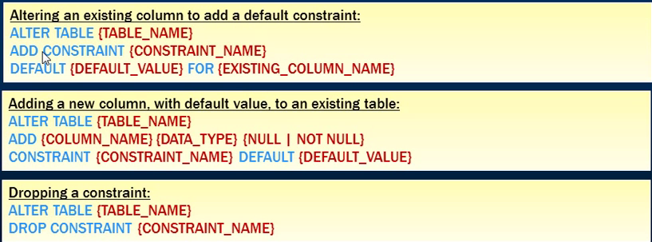
   3. If null is inserted in the query, then the default will not be inserted into the table
5. Cascading referential integrity constraint
   1. If a row in foreign table is deleted, the corresponding row values will be changed according to the following
   2. 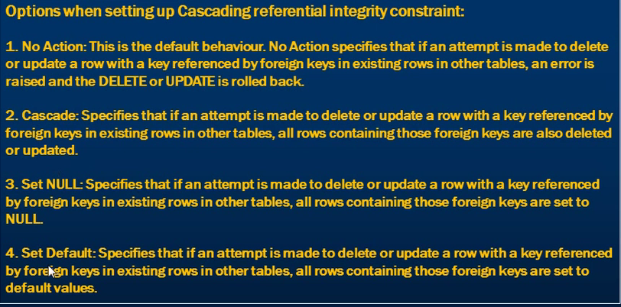
6. Check constraints
   1. Right click on constraint folder under the table
   2. “Check constraint” dialog box opens.
   3. Enter the Boolean expression
   4. Once done the value entered in the table passes thru the expression and only when it succeed the expression it will insert, else it will throw a exception
   5. 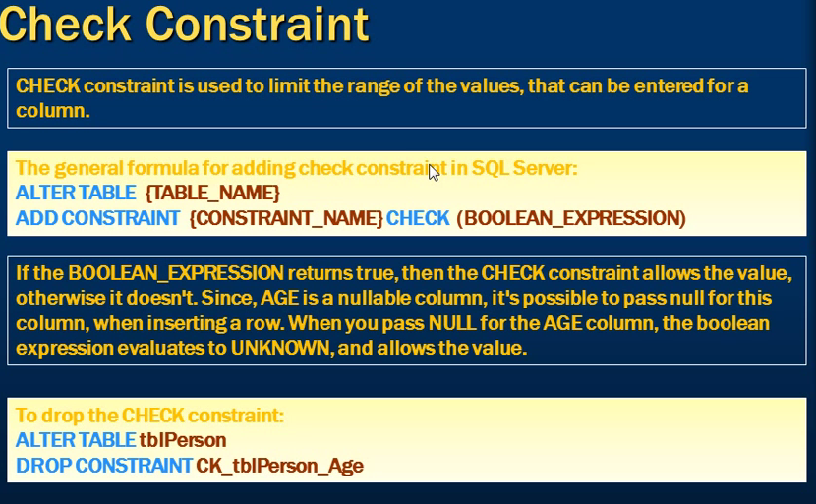
7. Identity Column
   1. Is Identity, Identity seed and Identity increment.
   2. If we need to insert an value to a identity column, we need to set identity insert to ON
   3. Syntax:setIdentity_insert<TableName> ON
   4. If the identity insert is set to on we need to explicitly give value to all the insert
   5. 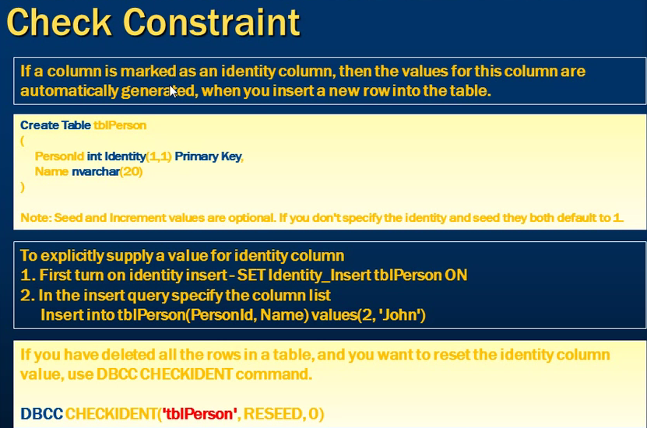
   6. To reset the identity after deleting all the values from a table use the following command to reset the seed. : DBCC CHECKIDNT (‘<tableName>’,REDEED,0)
8. Get the last generated Identity column
   1. SCOPE_IDENTITY() – return the last generated value of the same session and same scope
   2. @@Identity – return the last generated value of the same session and across any scope
   3. IDENT_CURRENT(‘TableName’ ) – Specific table across any session and any scope
9. Unique key constraint
   1. 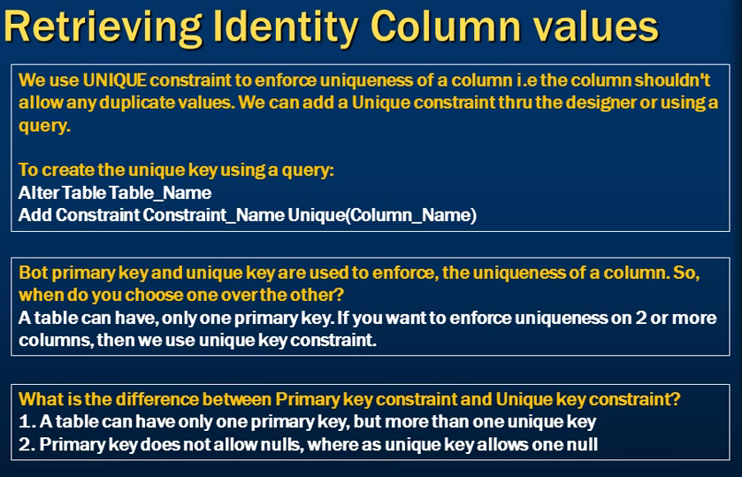
10. Select Statement in SQL.
    1. Distint
    2. Where
    3. <> , != used for not operator
    4. 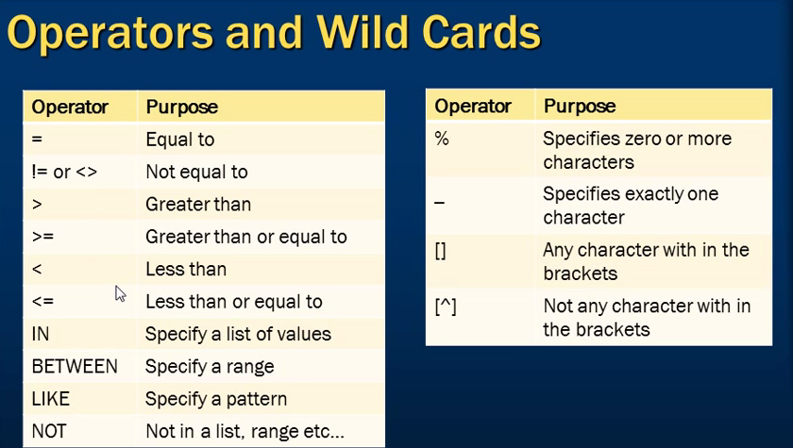
    5. [] – is used in like to get more than one char in the pattern ex: **select * from <tablename> where name like ‘[MSD]%’ –** will get the values starting with M,S,D
    6. [^] – is used in like to get the inverse more than one char in the pattern ex: **select * from <tablename> where name like ‘[^MSD]%’ –** will get the values which are not starting with M,S,D
    7. Order by, DESC, ASC
    8. Top x, Top x Percent – where x is the integer
11. Group by
    1. Aggregate functions : SUM, Average, Min, Max,
    2. Order by
    3. Where and having(Difference)
    4. 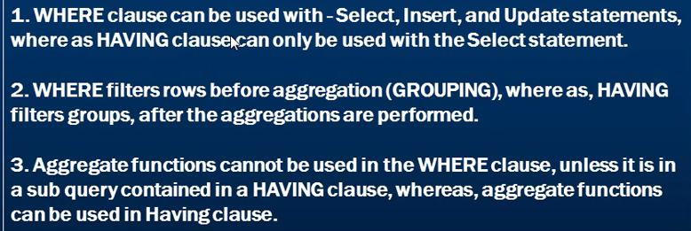
    5. 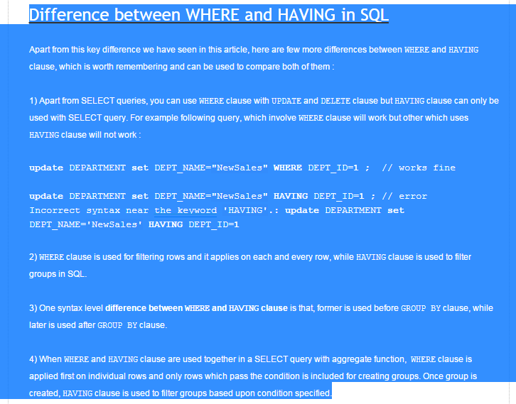
12. Joins
    1. INNER JOIN or join - Matching rows only and Non matching rows are eliminated
    2. OUTER JOIN
       1. LEFT JOIN - Matching rows and Non matching rows are from the left table
       2. RIGHT JOIN - Matching rows and Non matching rows are from the right table
       3. FULL JOIN - Matching rows and Non matching rows from both table
    3. CROSS JOIN – Cartesian product of both table and does not have a ON clause
    4. 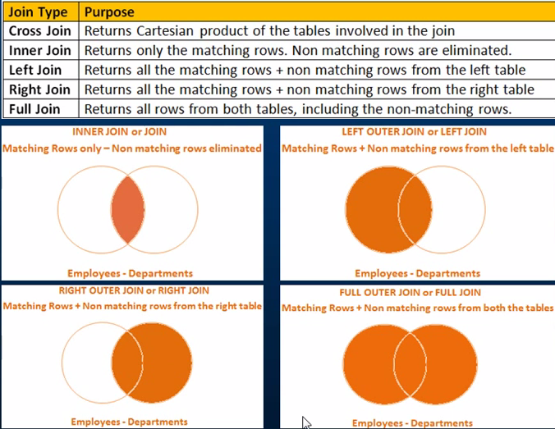
13. Advanced or Intelligent Joins
    1. Get the Non matching rows of the left table and right table
    2. 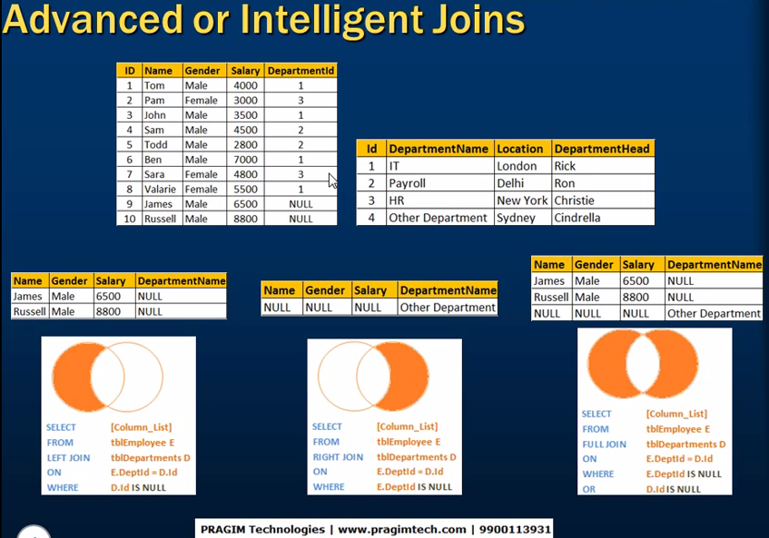
    3. Never ever use “equal to” operator when comparing NULL.
14. Self-join
    1. Joining a table with itself
    2. Types
       1. Inner
       2. Outer : (Left, Right, Full)
       3. Cross
    3. 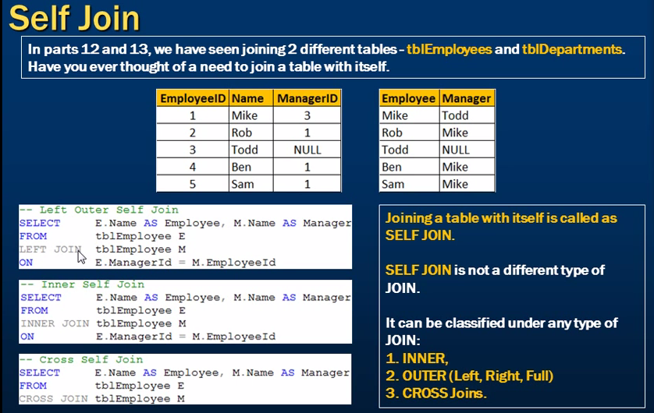
15. Replace NULL
    1. ISNULL() Function, CASE Statement and COALESCE()
    2. 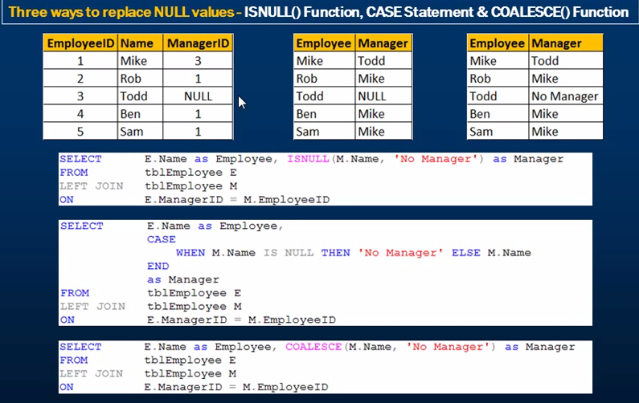
16. COALESCE()
    1. 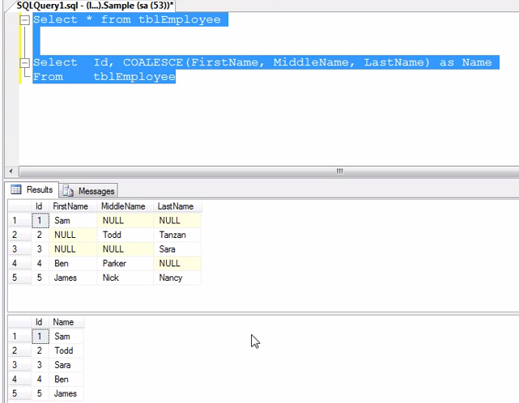
17. UNION and UNION ALL
    1. UNION ALL – union two result set with duplicates
    2. UNOIN - union two resulted set removing duplicates
    3. 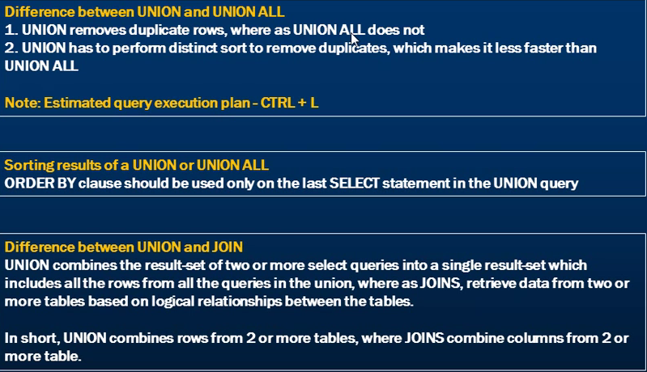
    4. 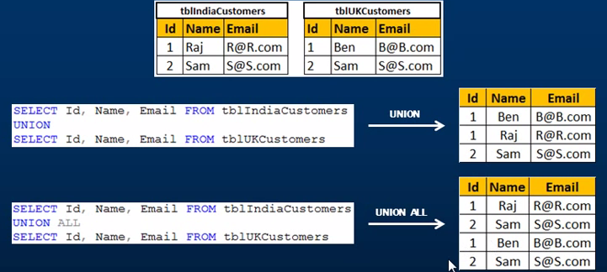
    5. 
18. Stored procedure
    1. 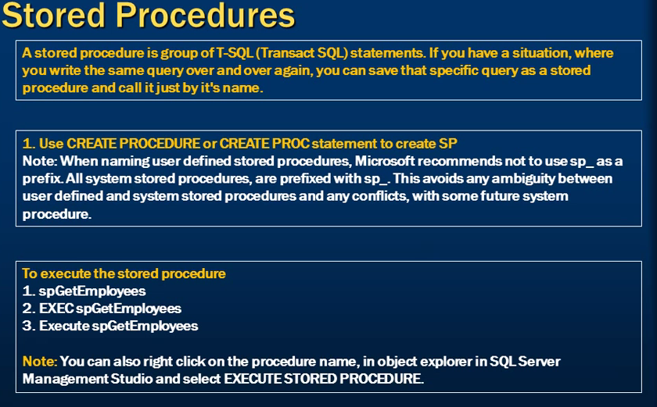
    2. 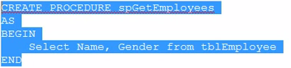
    3. 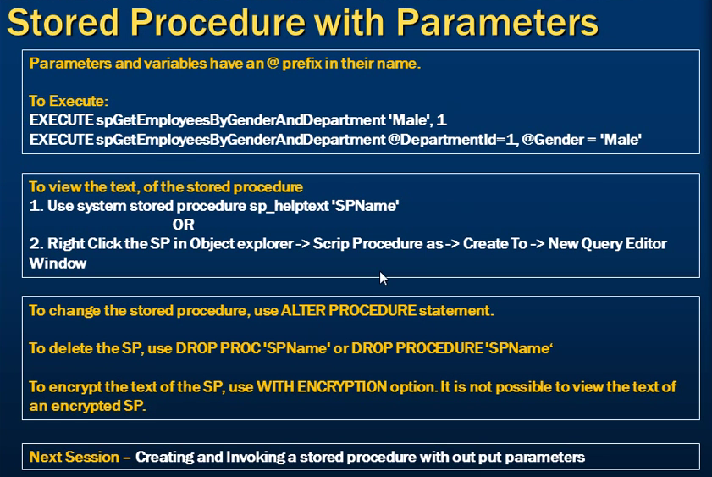
    4. 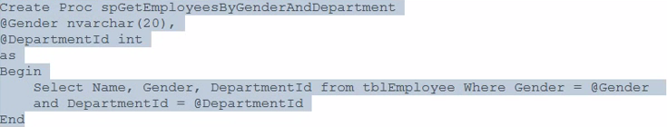
    5. To create a Stored proc use the above syntax and to execute the Stored proc use the below syntax
    6. 
    7. 
    8. Sp_Helptext**<Stored proc name>**- To get the stored procedure text
    9. 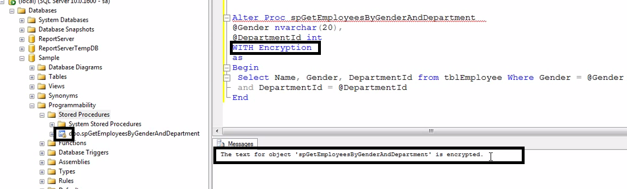
19. Stored proc with output parameter
    1. 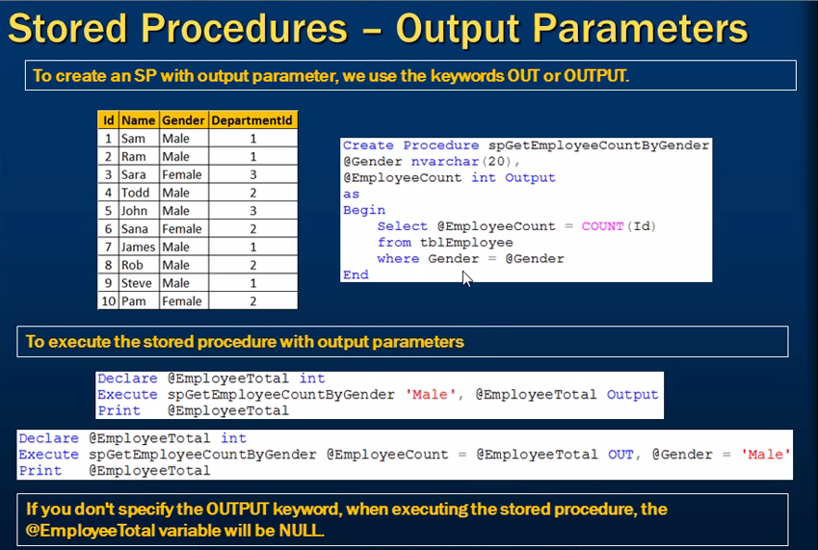
    2. 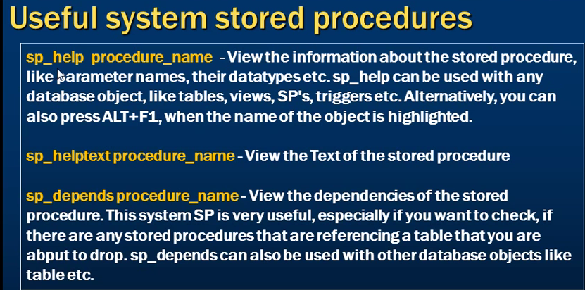
20. Stored procedure output parameter and return values
    1. 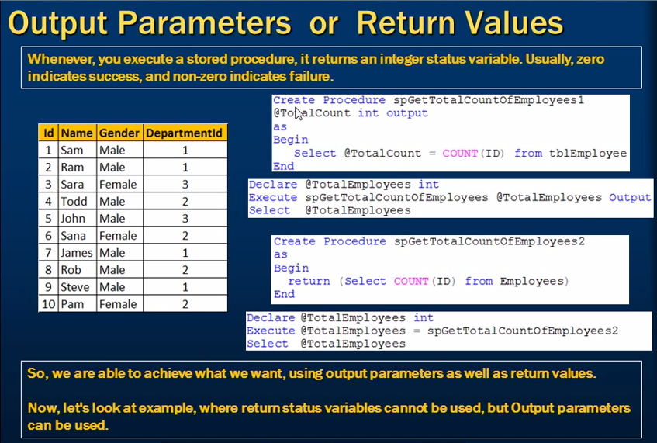
    2. 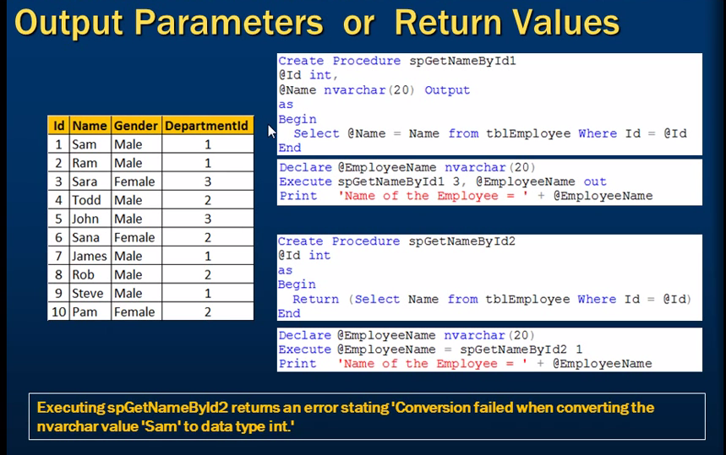
    3. 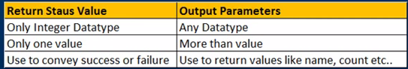
21. Advantages of Stored Procedure
    1. 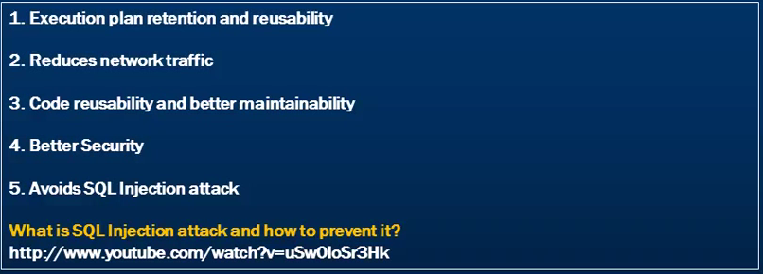
22. Build in Function
    1. Two types : Build In and User defined
    2. 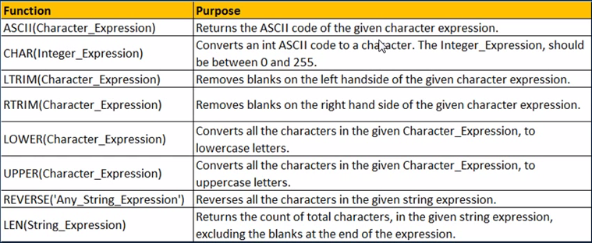
23. String functions
    1. 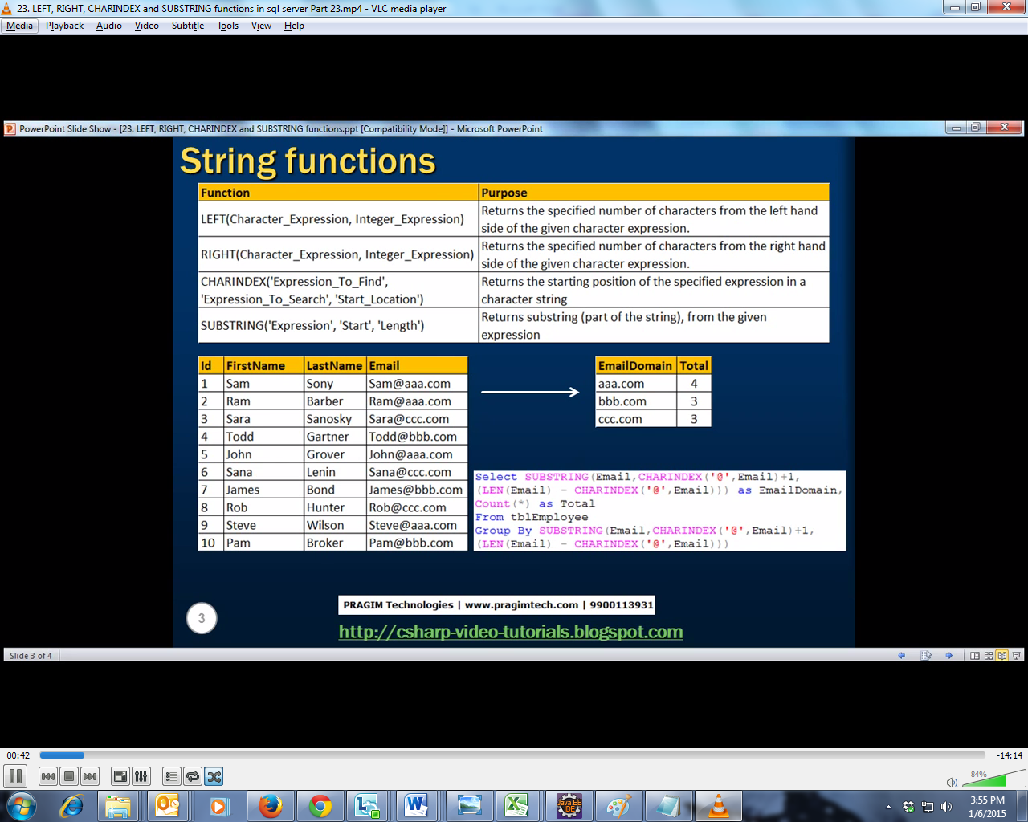
24. More on string function
    1. Replicate(int,string) – repeats the given string for the specified no of times
    2. Space(int)– repeats the space for the specified no of times
    3. Patindex(string, string) – returns the pattern index of the in the string
    4. Replace(string, string)- replace the occurrence the string
    5. Stuff(String,int,int,string) – stuff the given string in the original string for the specified string
25. Date functions
    1. 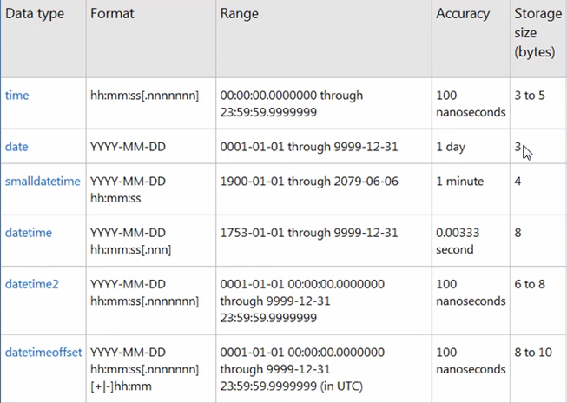
    2. 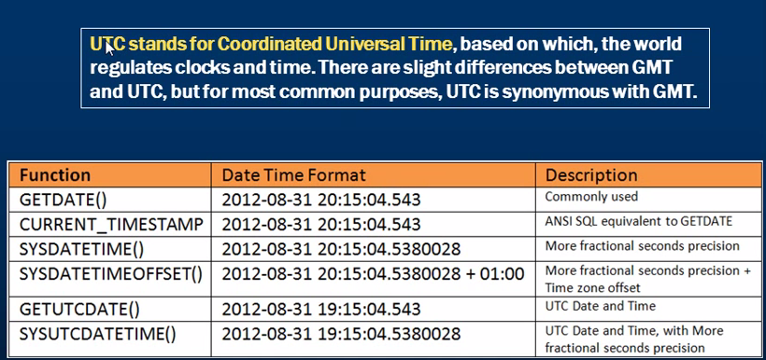
26. More on date functions
    1. Isdate, day, month, year, datename
    2. IsDate returns 0 for non-date and 1 for valid date
    3. IsDate also returns 0 for datetime2 and datetimeoffset whose millisecond value is larger
    4. Day, month, year returns the day, month and year of the given date
    5. 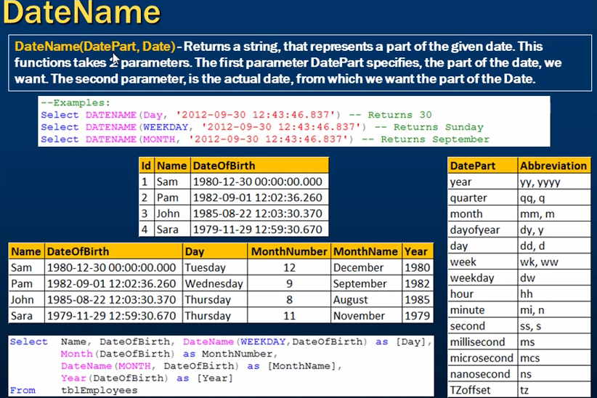
27. 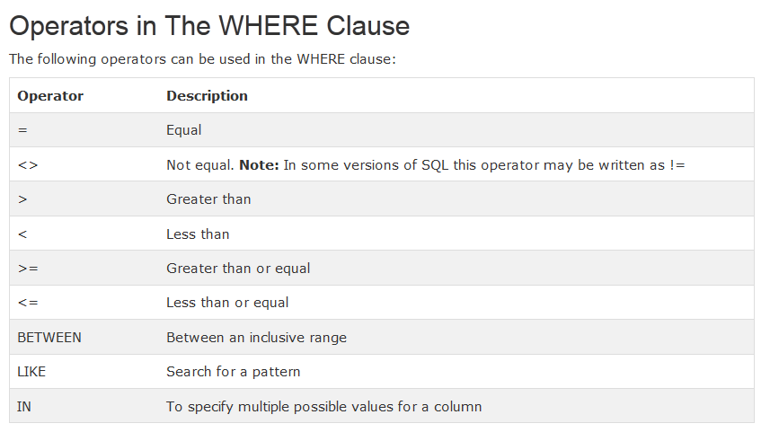

# Query syntax

|  |  |
| --- | --- |
| **Action** | **Query** |
| Create Database | Create database <Database name> |
| Change DB name | Alter database <Database name> modify name=<New name> |
| Change DB name using SP | Execute sp_renameDB ‘OldDBName’ ‘NewDBName’ |
| Deleting a Database | Drop database <databasename> |
| Adding a foreign key | Alter table <tblName> add constraint <Constraint name> Foreign Key (<Column Name>) references <Foreign table>(<Foreign column>) |
| Default constraint |  |
| Check constraint |  |
| Set identity insert | set Identity_insert<TableName> ON |
| DISTINCT | SELECT DISTINCT column_name,column_name FROM table_name; |
|  |  |

# SQL Short cuts

* Alt + F1 – properties of a table

## SQL Tutorial

[SQL HOME](http://www.w3schools.com/sql/default.asp)

[SQL Intro](http://www.w3schools.com/sql/sql_intro.asp)

[SQL Syntax](http://www.w3schools.com/sql/sql_syntax.asp)

[SQL Select](http://www.w3schools.com/sql/sql_select.asp)

[SQL Distinct](http://www.w3schools.com/sql/sql_distinct.asp)

[SQL Where](http://www.w3schools.com/sql/sql_where.asp)

[SQL And& Or](http://www.w3schools.com/sql/sql_and_or.asp)

[SQL Order By](http://www.w3schools.com/sql/sql_orderby.asp)

[SQL Insert Into](http://www.w3schools.com/sql/sql_insert.asp)

[SQL Update](http://www.w3schools.com/sql/sql_update.asp)

[SQL Delete](http://www.w3schools.com/sql/sql_delete.asp)

[SQL Injection](http://www.w3schools.com/sql/sql_injection.asp)

[SQL Select Top](http://www.w3schools.com/sql/sql_top.asp)

[SQL Like](http://www.w3schools.com/sql/sql_like.asp)

[SQL Wildcards](http://www.w3schools.com/sql/sql_wildcards.asp)

[SQL In](http://www.w3schools.com/sql/sql_in.asp)

[SQL Between](http://www.w3schools.com/sql/sql_between.asp)

[SQL Aliases](http://www.w3schools.com/sql/sql_alias.asp)

[SQL Joins](http://www.w3schools.com/sql/sql_join.asp)

[SQL Inner Join](http://www.w3schools.com/sql/sql_join_inner.asp)

[SQL Left Join](http://www.w3schools.com/sql/sql_join_left.asp)

[SQL Right Join](http://www.w3schools.com/sql/sql_join_right.asp)

[SQL Full Join](http://www.w3schools.com/sql/sql_join_full.asp)

[SQL Union](http://www.w3schools.com/sql/sql_union.asp)

[SQL Select Into](http://www.w3schools.com/sql/sql_select_into.asp)

[SQL Insert Into Select](http://www.w3schools.com/sql/sql_insert_into_select.asp)

|  |  |
| --- | --- |
| **Insert into** | Normal insert statement |
| **Select into** | The SELECT INTO statement selects data from one table and inserts it into a new table. |
| **Insert into select** | The INSERT INTO SELECT statement selects data from one table and inserts it into an existing table. Any existing rows in the target table are unaffected. |

[SQL Create DB](http://www.w3schools.com/sql/sql_create_db.asp)

[SQL Create Table](http://www.w3schools.com/sql/sql_create_table.asp)

[SQL Constraints](http://www.w3schools.com/sql/sql_constraints.asp)

[SQL Not Null](http://www.w3schools.com/sql/sql_notnull.asp)

[SQL Unique](http://www.w3schools.com/sql/sql_unique.asp)

[SQL Primary Key](http://www.w3schools.com/sql/sql_primarykey.asp)

[SQL Foreign Key](http://www.w3schools.com/sql/sql_foreignkey.asp)

[SQL Check](http://www.w3schools.com/sql/sql_check.asp)

[SQL Default](http://www.w3schools.com/sql/sql_default.asp)

[SQL Create Index](http://www.w3schools.com/sql/sql_create_index.asp)

1. Two types :
   1. Index – allow duplicates
   2. Unique index – do not allow duplicates.

[SQL Drop](http://www.w3schools.com/sql/sql_drop.asp)

|  |  |
| --- | --- |
| DELETE | The DELETE command is used to remove rows from a table. A WHERE clause can be used to only remove some rows. If no WHERE condition is specified, all rows will be removed |
| TRUNCATE | TRUNCATE removes **all rows** from a table. The operation cannot be rolled back and no triggers will be fired. As such, TRUCATE is faster and doesn't use as much undo space as a DELETE. |
| DROP | The DROP command removes a table from the database. All the tables' rows, indexes and privileges will also be removed. No DML triggers will be fired. The operation cannot be rolled back. |

[SQL Alter](http://www.w3schools.com/sql/sql_alter.asp)

[SQL Auto Increment](http://www.w3schools.com/sql/sql_autoincrement.asp)

[SQL Views](http://www.w3schools.com/sql/sql_view.asp)

[SQL Dates](http://www.w3schools.com/sql/sql_dates.asp)

|  |  |  |
| --- | --- | --- |
| **Function** | **Description** | **Query** |
| [GETDATE()](http://www.w3schools.com/sql/func_getdate.asp) | Returns the current date and time | SELECT GETDATE() AS CurrentDateTime |
| [DATEPART()](http://www.w3schools.com/sql/func_datepart.asp) | Returns a single part of a date/time | SELECT DATEPART(yyyy,OrderDate) AS OrderYear, DATEPART(mm,OrderDate) AS OrderMonth, DATEPART(dd,OrderDate) AS OrderDay FROM OrdersWHERE OrderId=1 |
| [DATEADD()](http://www.w3schools.com/sql/func_dateadd.asp) | Adds or subtracts a specified time interval from a date | SELECT OrderId,DATEADD(day,45,<DataColumn>) AS OrderPayDate FROM Orders |
| [DATEDIFF()](http://www.w3schools.com/sql/func_datediff.asp) | Returns the time between two dates | SELECT DATEDIFF(day,'2014-06-05','2014-08-05') AS DiffDate |
| [CONVERT()](http://www.w3schools.com/sql/func_convert.asp) | Displays date/time data in different formats | CONVERT(*data_type(length)*,*expression*,*style*)  Refer the link |

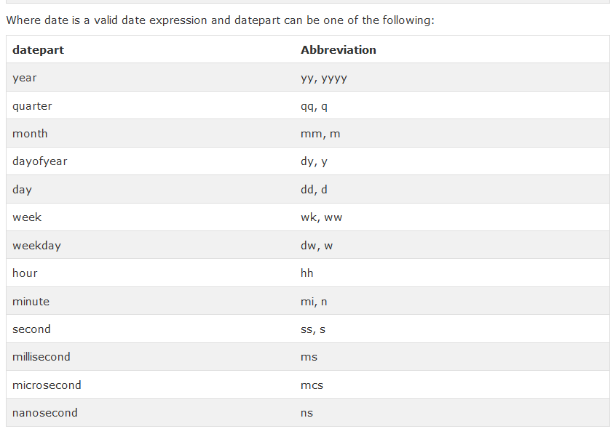

[SQL Null Values](http://www.w3schools.com/sql/sql_null_values.asp)

[SQL Null Functions](http://www.w3schools.com/sql/sql_isnull.asp)

COALESCE

[SQL Data Types](http://www.w3schools.com/sql/sql_datatypes_general.asp)

[SQL DB Data Types](http://www.w3schools.com/sql/sql_datatypes.asp)

## SQL Functions

[SQL Functions](http://www.w3schools.com/sql/sql_functions.asp)

[SQL Avg()](http://www.w3schools.com/sql/sql_func_avg.asp)

[SQL Count()](http://www.w3schools.com/sql/sql_func_count.asp)

[SQL First()](http://www.w3schools.com/sql/sql_func_first.asp)

[SQL Last()](http://www.w3schools.com/sql/sql_func_last.asp)

[SQL Max()](http://www.w3schools.com/sql/sql_func_max.asp)

[SQL Min()](http://www.w3schools.com/sql/sql_func_min.asp)

[SQL Sum()](http://www.w3schools.com/sql/sql_func_sum.asp)

[SQL Group By](http://www.w3schools.com/sql/sql_groupby.asp)

[SQL Having](http://www.w3schools.com/sql/sql_having.asp)

[SQL Ucase()](http://www.w3schools.com/sql/sql_func_ucase.asp)

[SQL Lcase()](http://www.w3schools.com/sql/sql_func_lcase.asp)

[SQL Mid()](http://www.w3schools.com/sql/sql_func_mid.asp)

[SQL Len()](http://www.w3schools.com/sql/sql_func_len.asp)

[SQL Round()](http://www.w3schools.com/sql/sql_func_round.asp)

[SQL Now()](http://www.w3schools.com/sql/sql_func_now.asp)

[SQL Format()](http://www.w3schools.com/sql/sql_func_format.asp)  
[SQL Quick Ref](http://www.w3schools.com/sql/sql_quickref.asp)

[SQL Hosting](http://www.w3schools.com/sql/sql_hosting.asp)

## SQL Quiz

[SQL Quiz](http://www.w3schools.com/sql/sql_quiz.asp)

|  |  |
| --- | --- |
| **SQL Statement** | **Syntax** |
| AND / OR | SELECT column_name(s) FROM table_name WHERE condition AND|OR condition |
| ALTER TABLE | ALTER TABLE table_name ADD column_namedatatype  or  ALTER TABLE table_name DROP COLUMN column_name |
| AS (alias) | SELECT column_name AS column_alias FROM table_name  or  SELECT column_name FROM table_name  AS table_alias |
| BETWEEN | SELECT column_name(s) FROM table_name WHERE column_name BETWEEN value1 AND value2 |
| CREATE DATABASE | CREATE DATABASE database_name |
| CREATE TABLE | CREATE TABLE table_name ( column_name1 data_type, column_name2 data_type, column_name3 data_type, ... ) |
| CREATE INDEX | CREATE INDEX index_name ON table_name (column_name)  or  CREATE UNIQUE INDEX index_name ON table_name (column_name) |
| CREATE VIEW | CREATE VIEW view_name AS SELECT column_name(s) FROM table_name WHERE condition |
| DELETE | DELETE FROM table_name WHERE some_column=some_value  or  DELETE FROM table_name (**Note:** Deletes the entire table!!)  DELETE * FROM table_name (**Note:** Deletes the entire table!!) |
| DROP DATABASE | DROP DATABASE database_name |
| DROP INDEX | DROP INDEX table_name.index_name (SQL Server) DROP INDEX index_name ON table_name (MS Access) DROP INDEX index_name (DB2/Oracle) ALTER TABLE table_name DROP INDEX index_name (MySQL) |
| DROP TABLE | DROP TABLE table_name |
| EXISTS | IF EXISTS (SELECT * FROM table_name WHERE id = ?) BEGIN --do what needs to be done if exists END ELSE BEGIN --do what needs to be done if not END |
| GROUP BY | SELECT column_name, aggregate_function(column_name) FROM table_name WHERE column_name operator value GROUP BY column_name |
| HAVING | SELECT column_name, aggregate_function(column_name) FROM table_name WHERE column_name operator value GROUP BY column_name HAVING aggregate_function(column_name) operator value |
| IN | SELECT column_name(s) FROM table_name WHERE column_name IN (value1,value2,..) |
| INSERT INTO | INSERT INTO table_name VALUES (value1, value2, value3,....)  *or*  INSERT INTO table_name (column1, column2, column3,...) VALUES (value1, value2, value3,....) |
| INNER JOIN | SELECT column_name(s) FROM table_name1 INNER JOIN table_name2  ON table_name1.column_name=table_name2.column_name |
| LEFT JOIN | SELECT column_name(s) FROM table_name1 LEFT JOIN table_name2  ON table_name1.column_name=table_name2.column_name |
| RIGHT JOIN | SELECT column_name(s) FROM table_name1 RIGHT JOIN table_name2  ON table_name1.column_name=table_name2.column_name |
| FULL JOIN | SELECT column_name(s) FROM table_name1 FULL JOIN table_name2  ON table_name1.column_name=table_name2.column_name |
| LIKE | SELECT column_name(s) FROM table_name WHERE column_name LIKE pattern |
| ORDER BY | SELECT column_name(s) FROM table_name ORDER BY column_name [ASC|DESC] |
| SELECT | SELECT column_name(s) FROM table_name |
| SELECT * | SELECT * FROM table_name |
| SELECT DISTINCT | SELECT DISTINCT column_name(s) FROM table_name |
| SELECT INTO | SELECT * INTO new_table_name [IN externaldatabase] FROM old_table_name  *or*  SELECT column_name(s) INTO new_table_name [IN externaldatabase] FROM old_table_name |
| SELECT TOP | SELECT TOP number|percentcolumn_name(s) FROM table_name |
| TRUNCATE TABLE | TRUNCATE TABLE table_name |
| UNION | SELECT column_name(s) FROM table_name1 UNION SELECT column_name(s) FROM table_name2 |
| UNION ALL | SELECT column_name(s) FROM table_name1 UNION ALL SELECT column_name(s) FROM table_name2 |
| UPDATE | UPDATE table_name SET column1=value, column2=value,... WHERE some_column=some_value |
| WHERE | SELECT column_name(s) FROM table_name WHERE column_name operator value |